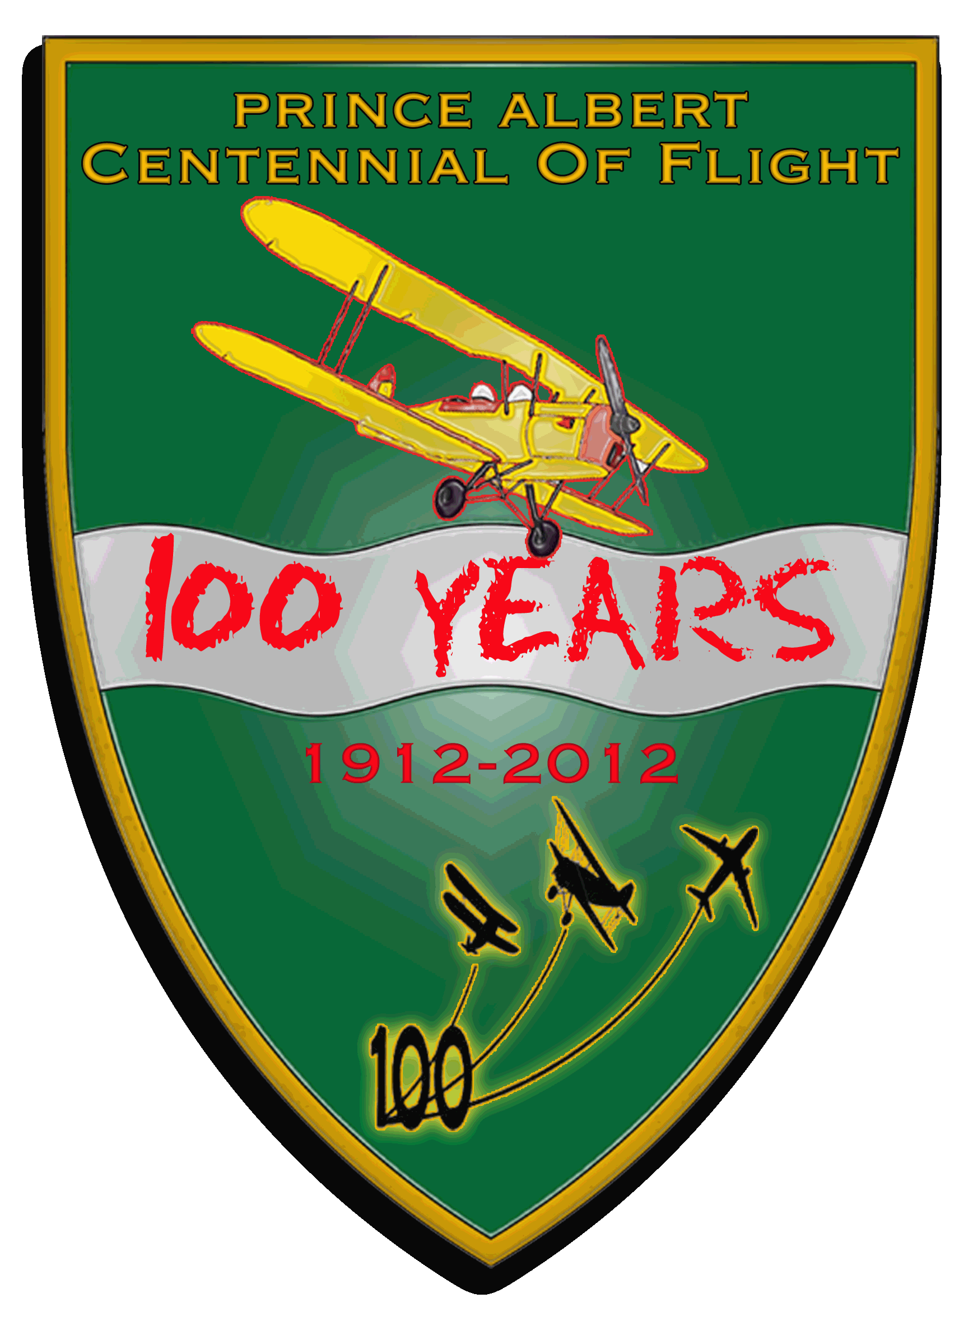 | Prince Albert Centennial of Flight Air Show Vendor Contract
 | Vendor Information .
______________________________  Company Name  _______________________________  Contact Person  ________________________________  Email  ____________________________________  Phone/ Fax |  | ____________________________________  Address  ____________________________________  City, Province  ____________________________________  Postal Code
Please indicate your vendor type:  - Not for profit, aviation related space: FREE (includes static displays)  - For profit, aviation related space: $200 (10’X10’ space)  - Not-for-profit, non-aviation related space: $100 (10’X10’ space)  - For profit, non-aviation related space: $100 (10’X10’ space) |  | The Prince Albert Centennial of Flight Air Show does not supply any amenities nor guarantee power.  You are responsible for supplying your own tents, tables, chairs etc.  All spaces can be doubled in size for double the price.
Vendor Description  Please give a brief description of the products or services that you wish to supply at your booth. This includes raffles/draws/give-aways/contests and sales.  Food vendors must adhere to and provide a copy of the Saskatchewan Health Region Services, Prince Albert Region safe food handling practices and fill out a participant application form for special event and trade shows as attached. |  | _________________________________________________  _________________________________________________  _________________________________________________  _________________________________________________  _________________________________________________  This application must be returned with full payment by July 13, 2012 to confirm space at the 2012 Prince Albert Centennial of Flight Air Show.  We will endeavour to allocate your space to create the most effective show.

Page 1 of 2 www.centennialofflight.ca August 4,5,& 6 2012.

Page 2 of 2 www.centennialofflight.ca August 4,5,& 6 2012

We, the undersigned, agree to pay the Centennial of Flight Air Show, Prince Albert Tourism (the Licensor) the appropriate space rate, GST included. We have read and understand the conditions of the application/contract on the reverse, and agree to abide by them. Faxed copies will be considered as an original application/contract with payment.
Please consider that your space is not reserved until full payment has been made.
Payment is due by July 13, 2012.
Cheques can be made payable to the Centennial of Flight Air Show, Prince Albert Tourism.

_______________________________________  Authorized Vendor Signature  _______________________________________  Please Print Name  _______________________________________  COF Representative Signature | __________________________________  Cheque Amount  __________________________________  Date Received  ___________________________________  Receivers Signature
Please make cheques payable to the Centennial of Flight Air Show, Prince Albert Tourism.  Cheques or money orders can be mailed with this form to:  Centennial of Flight, Prince Albert Tourism  3700 2nd Avenue West, Prince Albert, Sk  S6W 1A2 | If you have questions, please contact;  Debbie Honch @ 306-960-7039  Tim Munro @ 1-877-868-7470  Or 306-981-2011  Fax 306-922-8687

Contract/Space Application: READ CAREFULLY .

These regulations have been established for the mutual benefit and protection of exhibitors/visitors of Centennial of Flight Air Show.
1. Show move in 12:00pm – 6:00pm Saturday, August 4/12.
2. Show move out times – directly after the show. There will not be any security over night.
3. Show Days: August 5, 2012 - Gates open at 10:00am; aerial show is from 2:00pm - 4:00pm, gates close at 6:00pm. All booths must remain fully set up from 10:00am until at least the end of the show (approx. 4:00pm).
4. You are paying for space only; tables/chairs/tents are to be brought by you. No guarantee of power available
5. Exhibitor agrees there will be NO subletting of their booth space.
6. Liability – Although security will be there through-out the air show, the Centennial of Flight Air Show and their volunteers can or will not be responsible for damage to, loss or theft of property belonging to, or injury to, any exhibitor, his agents, or employees. Each exhibitor is expected to carry his appropriate insurance. Upon signing this contract, exhibitor is signing a release.
7. Cancellation – in the event that this application is not accepted, space rental fees made to the Centennial of Flight Air Show will be returned. After acceptance of the application by the show, no amount paid or payable by the exhibitor is refundable in the event the exhibitor does not use the reserved space. The Centennial of Flight Air Show shall have full power to interpretation and enforcement of all rules and regulations contained herein.
8. Each 10’ x 10’ booth will receive 3 exhibitor passes to the Air Show that must be worn at all times. These do not give you admittance into any restricted or VIP areas. Exhibitors and all exhibitor materials must remain with-in the allotted space.
9. By signing this contract/space application, I am indicating that I have read the full contract and agree to all of the regulations of the Centennial of Flight Air Show and sign the contract of my own free will. Please sign at the top of this page.

